**How to configure the database for RMAN (Practical Demo)**

Step 1:Firstly connect with the target database , startup database , and configure listener, and create password file.

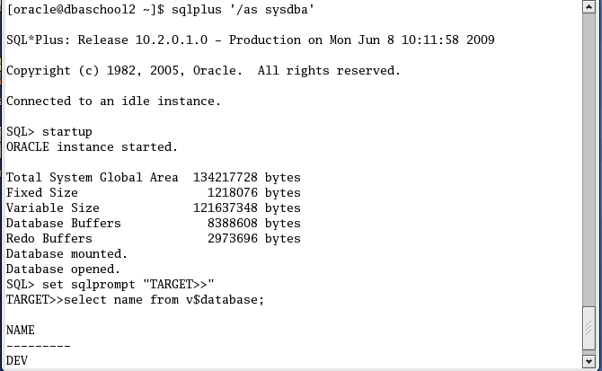

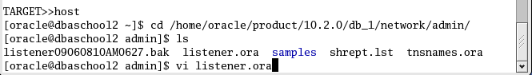

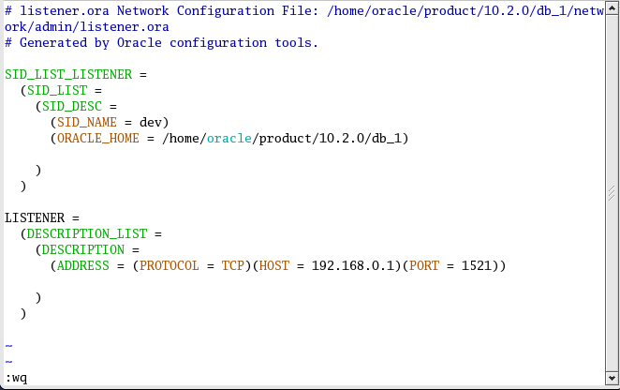



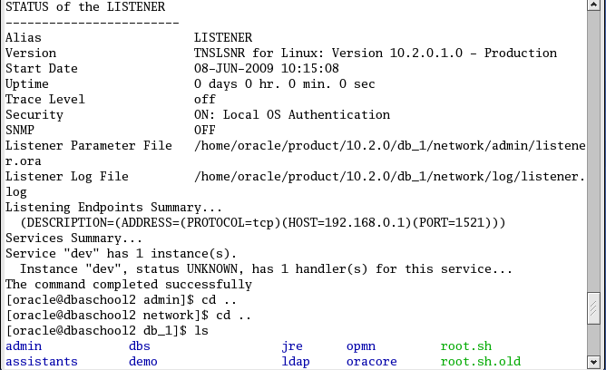

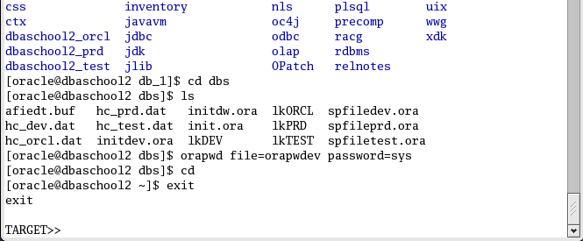

Step 2: Come on catalog side, firstly you configure the tnsnames.ora

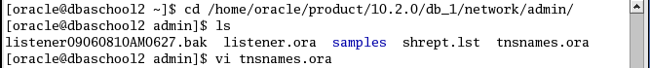

* 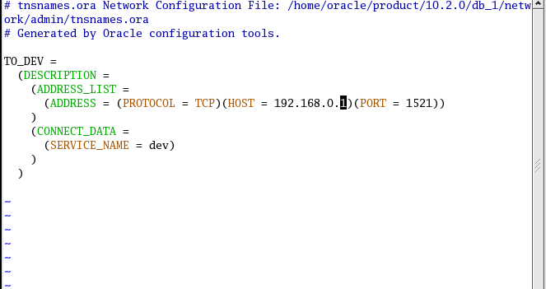
* 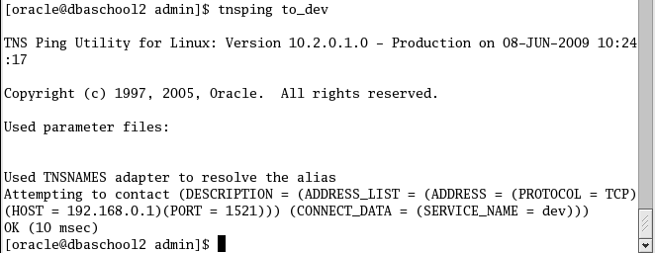

Step 3: Start one database, create a tablespace, create userrman and assign the tablespace to the user. Connect rman prompt and then create the catalog.

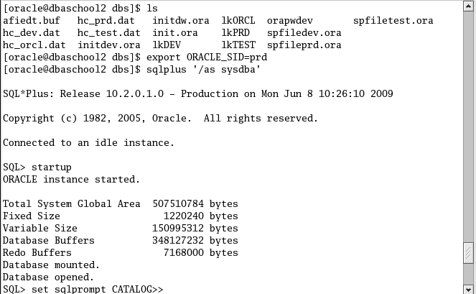

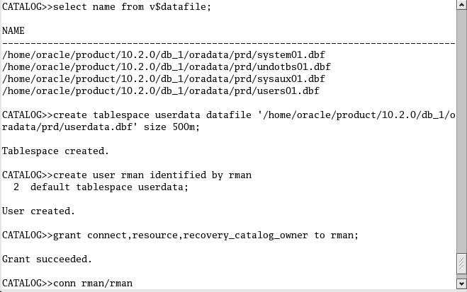

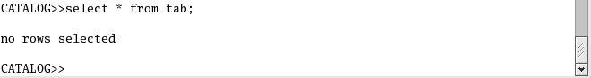

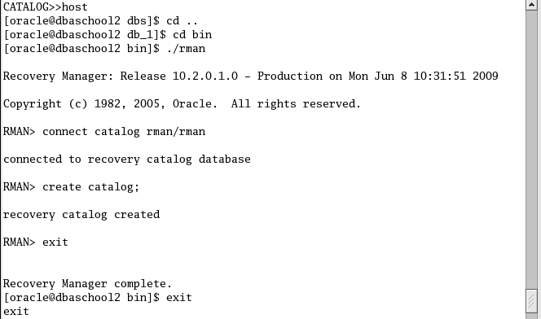

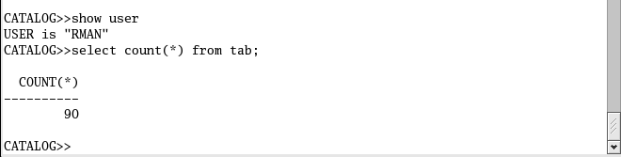



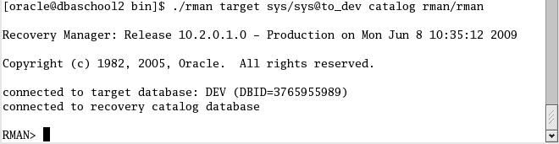

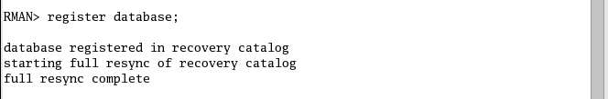

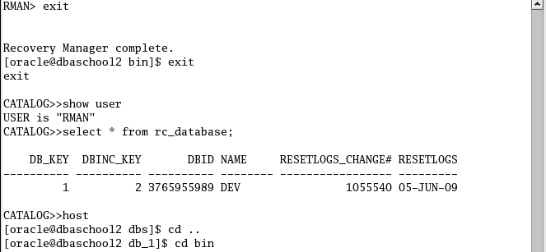

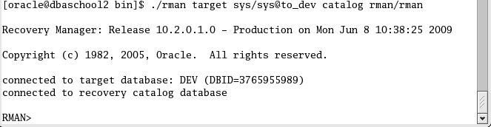

How to take a backup of the database

1. Full database backup

RMAN> Backup Database;

1. Tablespace level backup

RMAN> Backup Tablespace<tablespacename>

1. Datafile level backup

RMAN> Backup Datafile<datafile name>

1. Controlfile backup

RMAN> Backup current controlfile ;

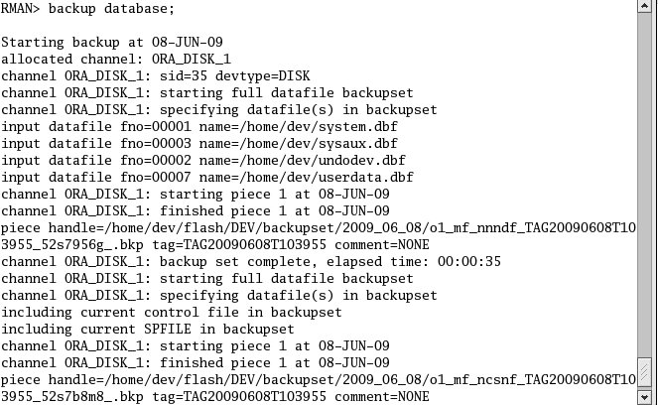

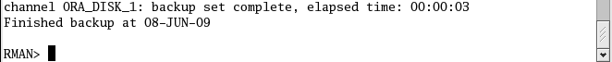

**Recover through RMAN**

1. Recovery when we lose c/r/d files in the target database

Go to target database and remove all c/r/d files.

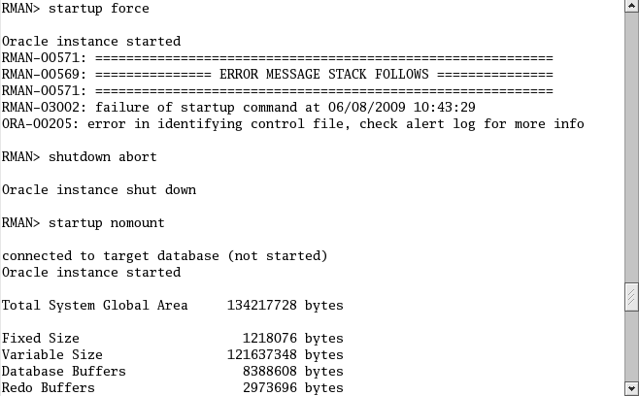

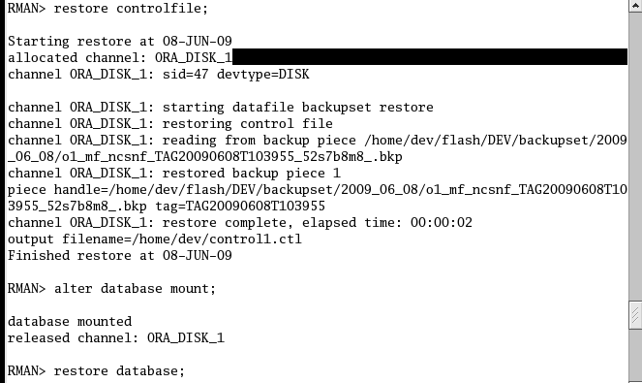

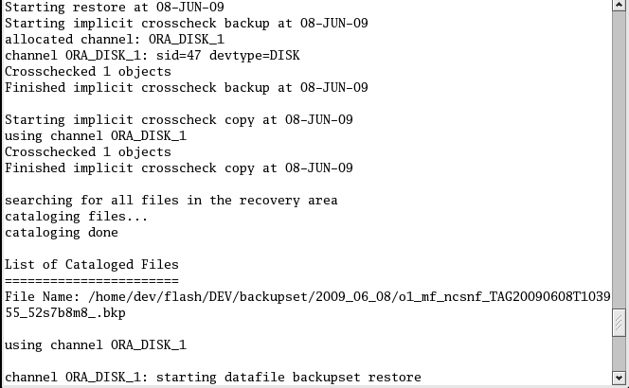

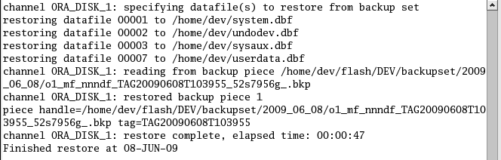

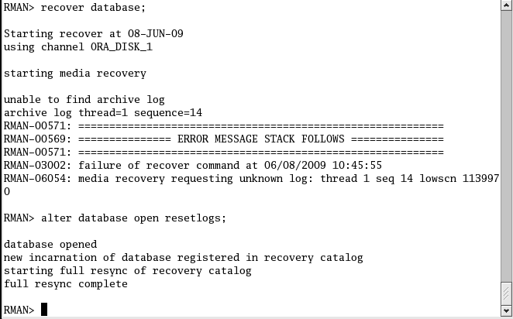

Take a fresh RMAN backup

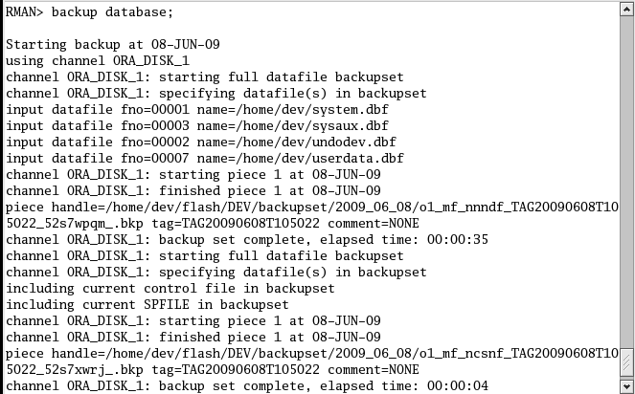

Case 2: recovery from loss of controlfile.

Go to target database and remove allcontrolfiles.

When a controlfie is lost, use shutdown abort command, restore controlfie and recover database.

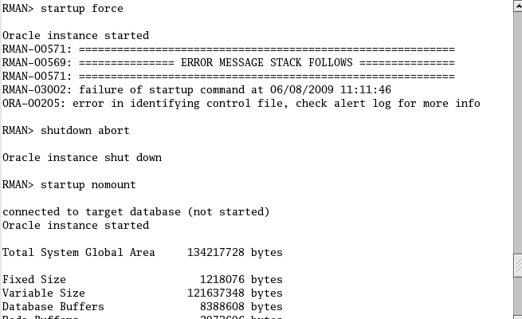

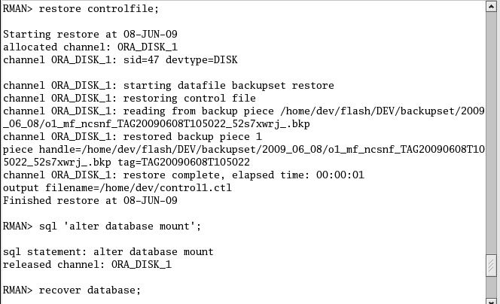

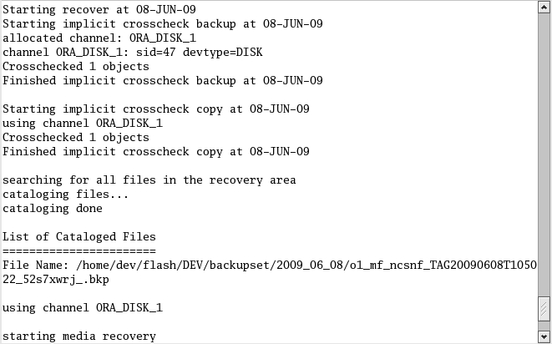

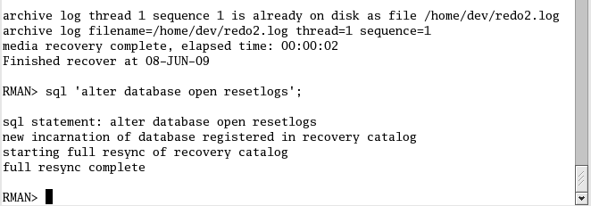

Take a fresh RMAN backup



**Case 3: recovery from loss of redologfiles.**

Go to target database removes all redo log files.

When we lose redo log files , go to target database remove all Datafiles and controlfiles. And then come on rman side to recover the database

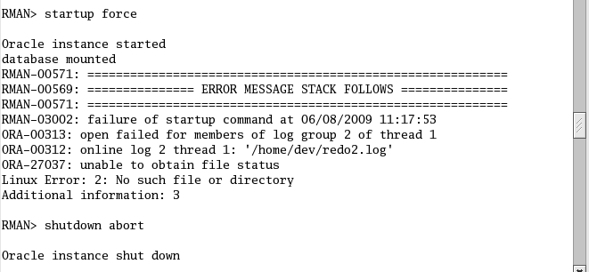

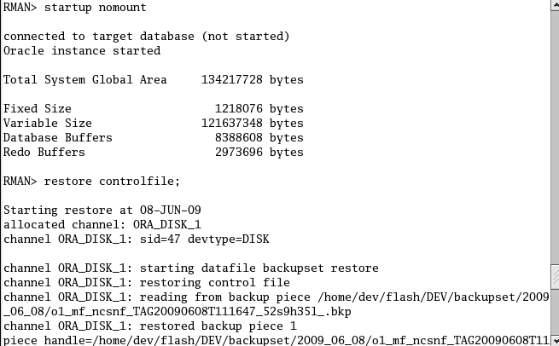

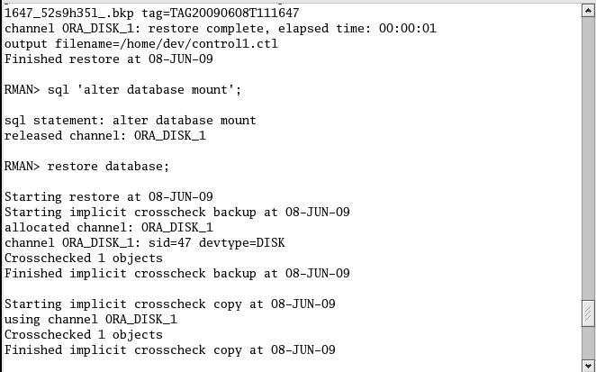

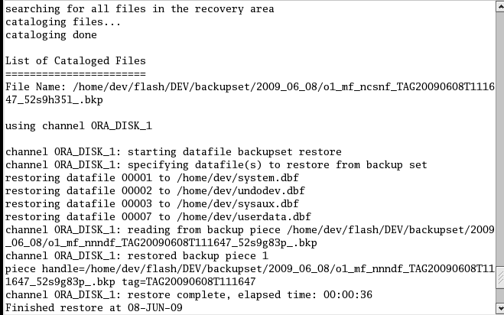

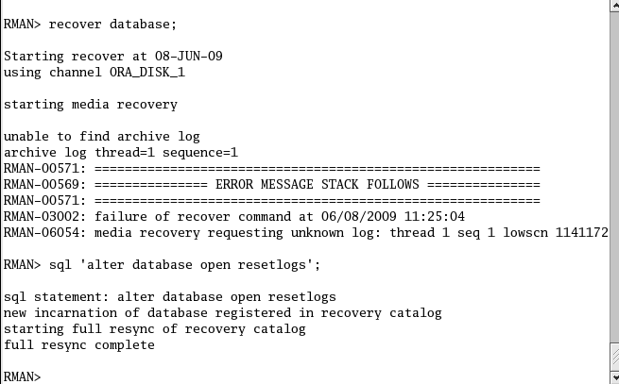

Take a fresh RMAN backup



Case 4: Recovery from non systemDatafiles lost

When a data filelost, make it offline (if you are performing oline recovery), restore lost data filefrom backup, recover data file.

Go to target database remove one datafile.

